**Portfolio of Sue Darby**

*Sue Darby*writes technical instructions for a variety of technical and crafting topics.|

***Sue Darby*** is a wizard with Office Suites… pick a Windows, Internet or Linux based variation and she can make Word, Excel, PowerPoint, Access, Publisher, Project, SharePoint and their counterparts do whatever is needed from basics to macros and things they weren’t originally programmed to do (mass e-mail merge PDF files through Outlook). She writes technical instructions from “This is the mouse” level to anything new that she’s done only once or twice. She can target instructions to the level of the audience as well for presentations. She also installs, sets up, maintains and secures efficient WordPress websites. She is a mother, published author, honors graduate and amateur photographer.

Sue is an experienced talent on the labor market. She is an explorer, ready for adventures abroad. She is an achiever, who is willing to work hard to reach goals. She is a team player, getting along well with people around her. Creativity is one of her strengths and she’s often up to try something new. She is a great asset to a team!

She is always willing to learn something new every day. Continuous personal development and adaptability are in high demand in a fast-changing work environment, thus sharing her learning motivation is important to her. She is determined to have a positive impact – not only on the working environment but on the whole of society.

[Contact me](http://www.sue-a-darby.com/contact-sue-today/)

[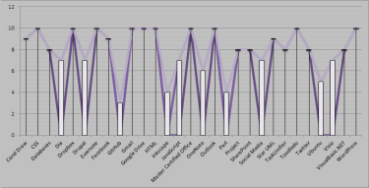](https://i2.wp.com/www.sue-a-darby.com/wp-content/uploads/education/chart-skill-chart-1.png)

[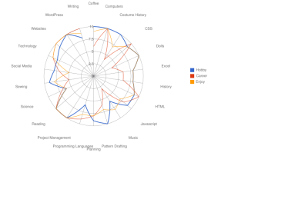](https://i0.wp.com/www.sue-a-darby.com/wp-content/uploads/misc/image.png)

[](https://i0.wp.com/www.sue-a-darby.com/wp-content/uploads/chartsgraphs/geek-1.png)

[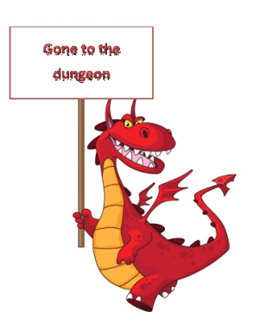](https://i1.wp.com/www.sue-a-darby.com/wp-content/uploads/miscworkplace/personality-Gone-to-the-Dungeon.png)

[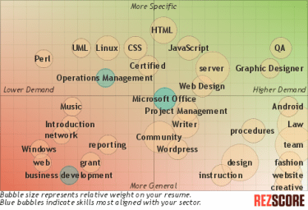](https://i0.wp.com/www.sue-a-darby.com/wp-content/uploads/chartsgraphs/index.png)

[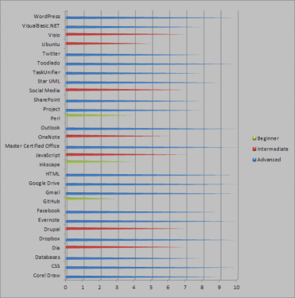](https://i2.wp.com/www.sue-a-darby.com/wp-content/uploads/education/chart-skill-chart-2-e1523671682572.png)

[](https://i2.wp.com/www.sue-a-darby.com/wp-content/uploads/education/chart-skill-chart-1.png)

[](https://i0.wp.com/www.sue-a-darby.com/wp-content/uploads/misc/image.png)

[](https://i0.wp.com/www.sue-a-darby.com/wp-content/uploads/chartsgraphs/geek-1.png)

[](https://i1.wp.com/www.sue-a-darby.com/wp-content/uploads/miscworkplace/personality-Gone-to-the-Dungeon.png)

[](https://i0.wp.com/www.sue-a-darby.com/wp-content/uploads/chartsgraphs/index.png)

[](https://i2.wp.com/www.sue-a-darby.com/wp-content/uploads/education/chart-skill-chart-2-e1523671682572.png)

[](https://i2.wp.com/www.sue-a-darby.com/wp-content/uploads/education/chart-skill-chart-1.png)

**Skills**

[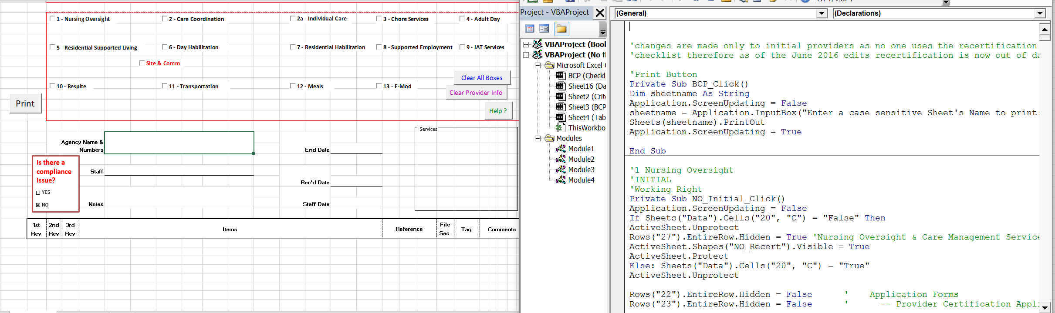](http://www.sue-a-darby.com/where-do-i-or-have-i-used-these-programs/)

[**Read more**](http://www.sue-a-darby.com/where-do-i-or-have-i-used-these-programs/)

[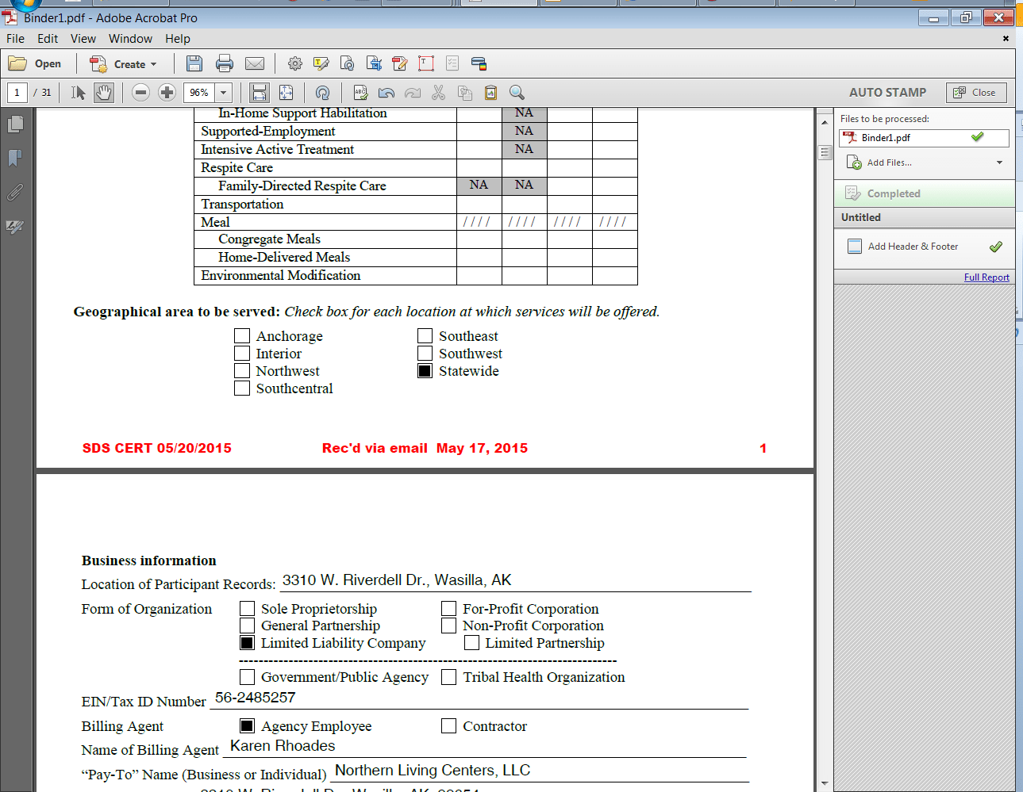](http://www.sue-a-darby.com/process-improvements/)

[**Read more**](http://www.sue-a-darby.com/process-improvements/)

**Achievements**

[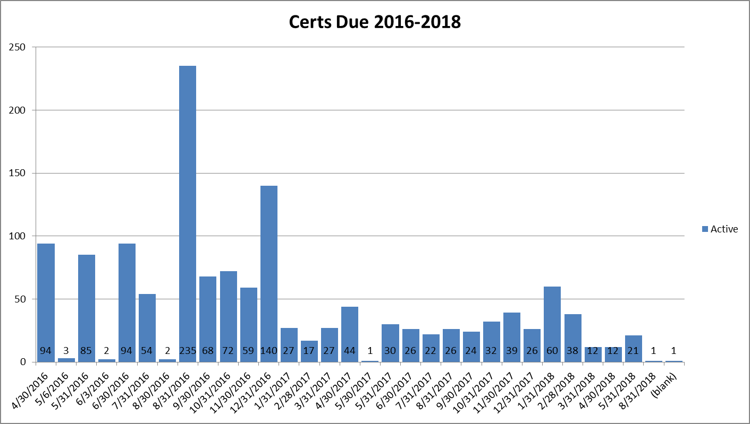](http://www.sue-a-darby.com/habilitation-providers/)

[**Read more**](http://www.sue-a-darby.com/habilitation-providers/)

[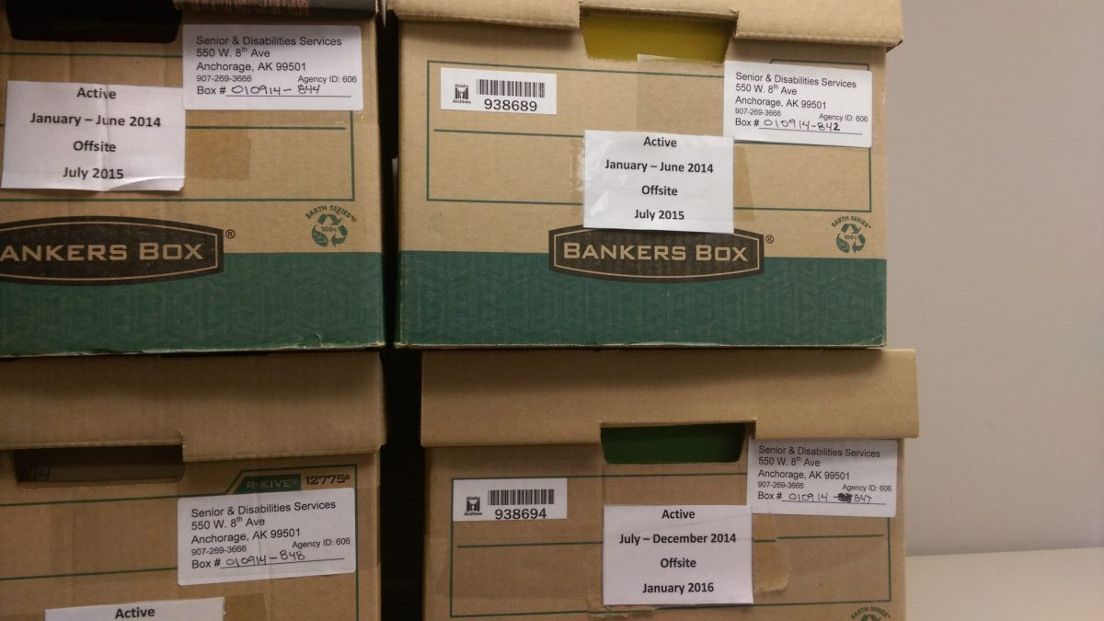](http://www.sue-a-darby.com/cost-savings-records-requests/)

[**Read more**](http://www.sue-a-darby.com/cost-savings-records-requests/)

**Personality**

For the last 5 years I have been the Admin Clerk II/Office Assistant I/Office Assistant II (a couple reclasses there) otherwise known as clerical support staff member, of the Division…

[**Read more**](http://www.sue-a-darby.com/just-the-clerk-not/)

[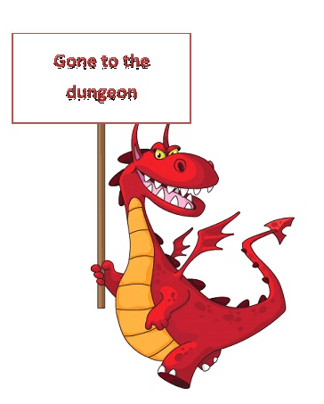](http://www.sue-a-darby.com/gone-to-the-dungeon/)

So today’s big project was a file inventory. We have hard files still, although that is slowly going digital finally. The gremlins and dragons in the dungeon otherwise known as…

[**Read more**](http://www.sue-a-darby.com/gone-to-the-dungeon/)

Education

* Charter College
* Solano College
* [Continuing Education](http://www.sue-a-darby.com/education-expanded)

Experience

* [Alaska Office Specialists](http://www.alaskaos.com/)
* [Books, Music & More](http://www.books-music-more.com/)
* [Coffee Institute](http://www.coffee-institute.com/)
* [Craft Pattern Emporium](http://www.craftpatternemporium.com/)
* [Sue’s Tiny Costumes](http://www.suestinycostumes.com/)
* [iA3](http://www.ia3.io/)
* State of Alaska
* Nine Star Education & Employment/Americorps

Network

* Gallery
* [Websites](http://www.sue-a-darby.com/website-network)
* Social Media

[RSS](http://www.alaskaos.com/feed/) [ALASKA OFFICE SPECIALISTS](http://www.alaskaos.com/)

* [Excel Tip](http://www.alaskaos.com/excel-tip/)

Continue reading Continue reading Excel Tip at Alaska Office Specialists.

* [G Suite](http://www.alaskaos.com/g-suite/)

Continue reading Continue reading G Suite at Alaska Office Specialists.

* [My “Official Job”](http://www.alaskaos.com/my-official-job/)

Continue reading Continue reading My “Official Job” at Alaska Office Specialists.

[RSS](http://codemonkey.sue-a-darby.com/rss) [CODE MONKEY’S TUTORIALS](http://codemonkey.sue-a-darby.com/)

* [Elementor Add On Elements Plugin](http://codemonkey.sue-a-darby.com/elementor-add-on-elements-plugin/)

Continue reading Continue reading Elementor Add On Elements Plugin at Code Monkey.

* [Add Ons for Elementor Plugin](http://codemonkey.sue-a-darby.com/add-ons-for-elementor-plugin/)

Continue reading Continue reading Add Ons for Elementor Plugin at Code Monkey.

* [Another Random Page](http://codemonkey.sue-a-darby.com/another-random-page/)

Continue reading Continue reading Another Random Page at Code Monkey.

Top of Form